

**INTERNATIONAL UNIVERSITY - HO CHI MINH CITY**

**VIETNAM NATIONAL UNIVERSITY**

**PROJECT – Snake Game**

**C/C++ PROGRAMMING IN UNIX**

***Date****: February 25th, 2020*

***Lecturer****: Tran Thanh Tung*

***Members****:*

1. *Pham Hoang Minh - ITITIU19031 (Leader)*
2. *Tran Minh Quang - ITITIU19192*
3. *Truong Nhat Minh Quang - ITITIU19194*
4. *Ha Minh Khoa - ITITIU19020*

***TABLE OF CONTENTS***

1. Members 2
2. Library 2
3. Food 2
4. Additional Features 2
5. Music 2
6. Game Status 2
7. Game Mode 2
8. Score database 3
9. Work Distribution 3
10. Citations 4

---ooo---

1. ***MEMBERS:***
2. Phạm Hoàng Minh - ITITIU19031 (Leader) (30%)
3. Trần Minh Quang - ITITIU19192 (70% / 3 ~ 23.33%)
4. Trương Nhật Minh Quang - ITITIU19194 (70% / 3 ~ 23.33%)
5. Hà Minh Khoa - ITITIU19020 (70% / 3 ~ 23.33%)
6. ***LIBRARY***

In order to complete this Snake Game, we are highly appreciated the use of SFML library. Therefore, we derive strong credit to the team who has coded this library.

1. ***FOOD***

There are three type of food in this game which are apple, melon and strawberry which is scored two (2), five (5) and ten (10), respectively.

1. ***ADDITIONAL FEATURES***
2. Music

In this game, we have selected six songs that are suitable with this game to boost efficiency: Those song are: Two Steps from Hell – Victory, Fade (Hell's Speaker Remix) Ft.Isabel Park - Alan Walker inspired, Khẩu thị tâm phi Remix, Move Your Body - Ria - Alan Walker Remix, N30N - Speed Nightcore, and a song with name is being unknowned. Moreover, they can choose to pause or replay that music again without causing troubles.

1. Game Status

We totally understand that when users are playing a game but having an immediate trouble to solve. In order to tackle this situation, we have included the Pause, Replay, Restart, Mode Changing, and Exit button to solve all of those troubles.

1. Game Mode:

By using five different functions with multiple of sub-functions, this game contains four different accessible Game Mode which is Single Easy, Single Hard, Double Easy and Double Hard where users can either choose to play alone or with friends. However, in order to clarify the difference between the Easy Mode and Hard, we have changed the delay variable, game rules and obstacles

Delay variable is the most important variables in determining the speed of snake. In the Easy Mode, the speed of the Snake is determined as:  whilst in the Hard Mode, delay is equal to 

|  |  |  |
| --- | --- | --- |
| Time Passed (s) | Delay (s) in Easy Mode | Delay (s) in Hard Mode |
| 0 | 0.15 | 0.1 |
| 30 | 0.1425 | 0.09 |
| 60 | 0.1353 | 0.081 |
| 90 | 0.1286 | 0.0729 |
| 120 | 0.1221 | 0.0656 |
| 150 | 0.116 | 0.059 |
| 180 | 0.1102 | 0.0531 |
| 240 | 0.0995 | 0.0478 |
| 300 | 0.0898 | 0.0348 |
| 450 | 0.0694 | 0.0205 |
| 600 | 0.0537 | 0.0121 |
| 900 | 0.0323 | 4.239 x 10-3 |
| 1200 | 0.0193 | 1.478 x 10-3 |
| 1800 | 6.91 x 10-3 | 1.797 x 10-4 |
| 2400 | 2.477 x 10-3 | 2.185 x 10-5 |
| 3600 | 3.184 x 10-4 | 3.229 x 10-7 |

*Table 1: The table compares the speed of Snake in term of “delay” variable in two Game Mode*

In terms of game rules, whilst in Easy Mode, Snake can choose to pass the wall if they want or not, in terms of Hard Mode, Snake cannot pass the wall, bite himself or another Snake (in Double Hard Mode)

Observing the Obstacle point, although Snake in both Game Modes are died if hitting the Obstacle, in Easy Mode, each 35 seconds passed, the number of obstacles increases by a value of 5. Meanwhile, the number of obstacles increases by a value of 15 after 45 seconds passed.

1. Score Database:

If users keep playing the game around one or two hours, they want to achieve some extent of satisfaction through score comparison. That is why we have set up function when users can check their points after playing a set. However, we do not store the score if users shut the game down as some articles points out if the score is being stored, player will continue playing over and over which decrease the working efficiency and attention, causing insomnia and headache.

1. ***WORK DISTRIBUTION:***

#1: Trần Minh Quang is the one who make GUI and How to play (Difficulty Level: 3.5 – 5 /10). Therefore, he can only gain 23% of score over the total as the leader have already taught him two (02) full lessons about the SFML Libraries and all of the possibilities and events to create one with full functions.

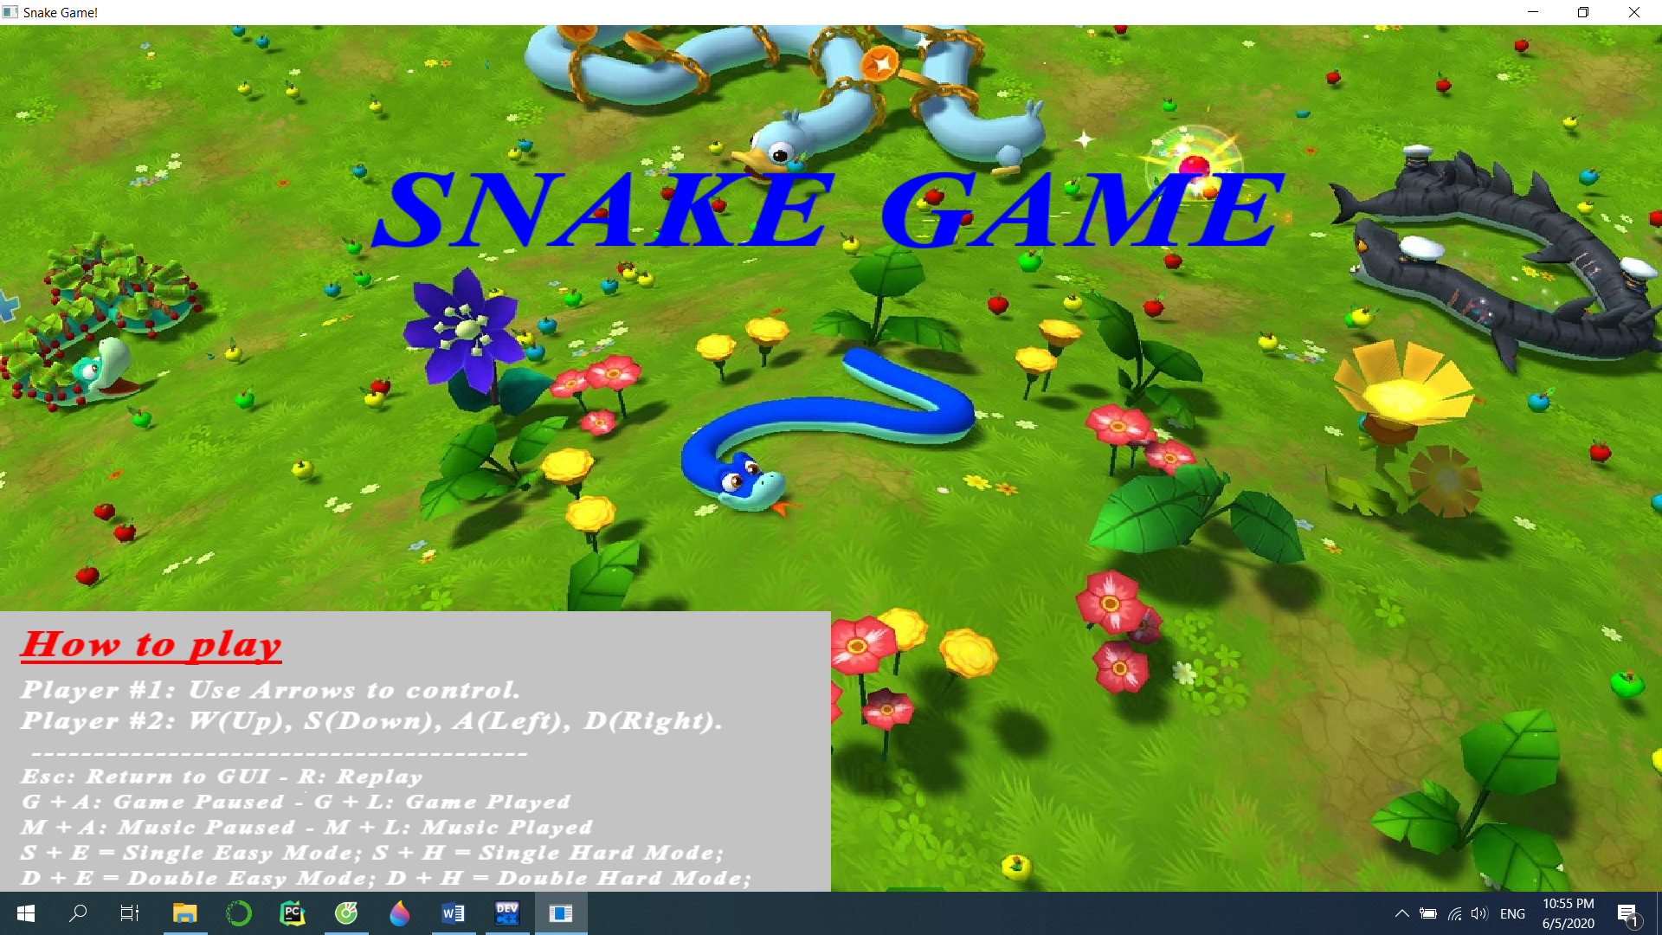

*Figure 01: The Cover of the Game*

#2: Trương Nhật Minh Quang is the one who make GameMode (both Easy and Hard) with Obstacles only (Difficulty Level: 3/10). Therefore, he can only gain 23% of score over the total as the leader have presented sample codes of Easy Mode already and he only needs to create the Hard Mode which is based on my Easy Mode code already.

#3: Hà Minh Khoa is the one who make “Replay” function, add Music when played, and Ended “Window” (Difficulty Level: 3/10). Therefore, he can only gain 23% of score over the total as the leader have already taught him two (02) full lessons about the SFML Libraries and all of the possibilities and events to create one with full functions.

#4: Phạm Hoàng Minh is the one who re-create the code, propose ideas, add more music, merge all of the discrete code from above, initialize the random for both Obstacles and Fruit, set up two other GameMode for players which are used for two players playing at the instance, and push up TeamMembers. Thus, as those tasks involved require large attention with ideas (with high difficulty ranging from 8.5 to 9), he can gain 30% of score over the total.

1. **CITATIONS**
2. SFML Library <https://www.sfml-dev.org/license.php>